**Software Requirements Specification**

**DevOps Group 3**

**Team Members: Harene d/o Pandi Raj (p2315788)**

**Ezell Low Qing Wei (p2315618)**

**Edward Ti Zhi Hao (p2220400)**

**Lim Jia Ning Vera (p2209278)**

Table of Contents

1. Purpose 2

1.1. Intended Audience 2

1.2. Intended Use 2

1.3. Scope 2

1.4. Definitions and Acronyms 2

2. Overall System Description 3

2.1. Use Case Diagrams 3

2.2. System Architecture 4

2.3. Functional Requirements 5

2.3.1. Start Up and Main Menu 5

2.3.2. Log in to website and start the car ..................................................................................... 8

2.3.3. Lock/Unlock car door and aircon control ........................................................................... 9

2.3.4. Car Theft Warning ………………………………………………………………………………………………………… 11

2.3.5. Remote Access .................................................................................................................. 13

2.3.6. Authentication Services ..................................................................................................... 14

2.4. Non-Functional Requirements ................................................................................................. 15

2.4.1. Power Management ......................................................................................................... 15

1. Software Architecture .................................................................................................................... 16

3.1. Static Software Architecture ..................................................................................................... 16

# Purpose

## Intended Audience

This SRS document describes the System Requirements and Software Design for a Vehicle Security and Telematics System and the target audience are System and Software Engineers working on the development of this project.

## Intended Use

The SRS defines the overall System Architecture and Requirements as well as the Software

Architecture and Design. This document also contains the definition of the System Requirements which shall be used as the input for System Test cases and Software Unit Test cases.

## Scope

## Definitions and Acronyms

|  |  |
| --- | --- |
| **Acronym** | **Description** |
| IR | Infra Red |
| LED | Light Emitting Diode |
| NFC | Near Field Communication |
| SW | Software |
| HW | Hardware |

# Overall System Description

## Use Case Diagrams

Vehicle Security System



User



Website

## System Architecture

The System Architecture

User interface

(website)



DC Motor



Buzzer



Temperature and Humidity Sensor



RFID

Card

Reader



SPI_

ADC_CH01



I2C



**Raspberry Pi Development Board**



GPIO



GPIO

23



GPIO

26



GPIO

24

## Functional Requirements

### Start Up and Main Menu

|  |  |
| --- | --- |
| **REQ_ID** | **Requirement** |
| REQ-01 | When the website is accessed for the first time, it will show a sign up page.  Line 1 = “Email Address: ”  Line 2 = “First name: ”  Line 3 = “Password: ”  Line 4 = “Password (Confirm): ”  Line 5 = “Verification Code: ” |
| REQ-02 | Once the sign up page is filled in, the website redirects to the login page.  Line 1 = “First name: ”  Line 2 = “Password: ” |
| REQ-03 | If users’ username exists and the password is typed correctly, a two-factor authentication page will pop up. To verify, user can enter their email.    Line 1= “Please verify your identity by entering your email.” |
| REQ-04 | When the car app is first logged in, the main menu with the text below shall be displayed on the web interface.    Line 1 = “Enter ‘1’ to power on car” |
| REQ-05 | In the main menu defined in REQ-04, if the option “Enter ‘1’ to power on car” is selected on the keyboard, then the following menu shall be displayed on the web interface.    Line 1 = “Enter 1 to lock/unlock car door”  Line 2 = “Enter 2 to control aircon”  Line 3 = “Fuel level = “  Line 4 = “Temperature = “  Line 5 = “Car Theft Warning: None ” |
| REQ-06 | In the main menu defined in REQ-05, if the option “Enter 1 to lock/unlock car door” is selected, the web interface should display the following text.    Line 1 = “Enter ‘1’ to unlock door”  Line 2 = “Enter ‘2’ to lock door” |
| REQ-07 | In the main menu defined in REQ-06, if the option “Enter ‘1’ to unlock door” is selected, the web interface should display the following text for 2 seconds and then enter into the Low Power Mode state defined in the State Machine in REQ-xx  Line 1 = “Door has unlocked.” |
| REQ-08 | In the main menu defined in REQ-06, if the option “Enter ‘2’ to lock door” is selected, the web interface should display the following text for 2 seconds and enter into the Low Power Mode state defined in the State Machine in REQ-xx  Line 1 = “Door has locked.” |
| REQ-09 | In the main menu defined in REQ-05, if the option “Enter 2 to control aircon” is selected, the web interface should display the following text.  Line 1 = “Enter desired temperature” |
| REQ-10 | In the main menu defined in REQ-09, the desired temperature entered, will be displayed on the web interface for 2 seconds and then enter into the Low Power Mode state defined in the State Machine in REQ-xx.  Line 1 = “Aircon is set to ___ ” |
| REQ-11 | In the main menu defined in REQ-05, if all doors of the car is locked and the door is forcefully opened, it will trigger the car alarm to sound and the web interfce should display the menu with the new following text.  Line 1 = “Enter 1 to lock/unlock car door”  Line 2 = “Enter 2 to control aircon”  Line 3 = “Fuel level = “  Line 4 = “Temperature = “  Line 5 = “Car Theft Warning: TRIGGERED “ |

### Log in to website and starting the car

|  |  |
| --- | --- |
| **REQ_ID** | **Requirement** |
| REQ-01 | When the website is accessed, it will show a login page.  Line 1= “First name: ”  Line 2= “Password: ” |
| REQ-02 | If users’ username exists and the password is typed correctly, a two-factor authentication page will pop up. To verify, user can enter their email.  Line 1= “Please verify your identity by entering your email.” |
| REQ-03 | When the website is first logged in, the main menu with the text below shall be displayed on the web interface.    Line 1 = “Enter ‘1’ to power on car ” |

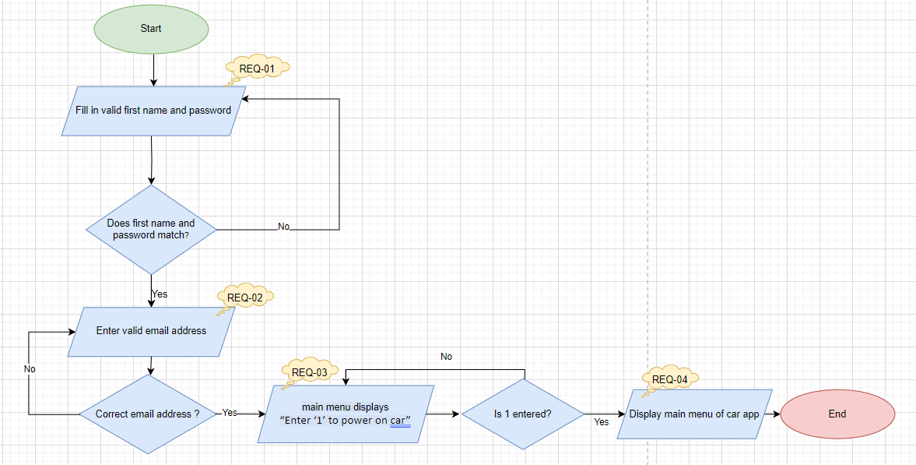

**Figure 1**

2.3.3 Lock/Unlock car door and aircon control

|  |  |
| --- | --- |
| **REQ_ID** | **Requirement** |
| REQ-04 | In the main menu defined in REQ-03, if the option “Enter ‘1’ to power on car” is selected on the keyboard, then the following menu shall be displayed on the web interface.    Line 1 = “Enter 1 to lock/unlock car door”  Line 2 = “Enter 2 to control aircon”  Line 3 = “Fuel level = “  Line 4 = “Temperature = “  Line 5 = “Car Theft Warning: None “ |
| REQ-05 | In the main menu defined in REQ-04, if the option “Enter 1 to lock/unlock car door” is selected, the web interface should display the following text.    Line 1 = “Enter ‘1’ to unlock door”  Line 2 = “Enter ‘2’ to lock door” |
| REQ-06 | In the main menu defined in REQ-05, if the option “Enter ‘1’ to unlock door” is selected, the web interface should display the following text for 2 seconds and then enter into the Low Power Mode state defined in the State Machine in REQ-xx.  Line 1 = “Door has unlocked.” |
| REQ-07 | In the main menu defined in REQ-05, if the option “Enter ‘2’ to lock door” is selected, the web interface should display the following text for 2 seconds and then enter into the Low Power Mode state defined in the State Machine in REQ-xx.  Line 1 = “Door has locked.” |
| REQ-08 | In the main menu defined in REQ-04, if the option “Enter 2 to control aircon” is selected, the web interface should display the following text.  Line 1 = “Enter desired temperature” |
| REQ-09 | In the main menu defined in REQ-08, the desired temperature entered, will be displayed on the web interface for 2 seconds and enter into the Low Power Mode state defined in the State Machine in REQ-xx.  Line 1 = “Aircon is set to ___” |

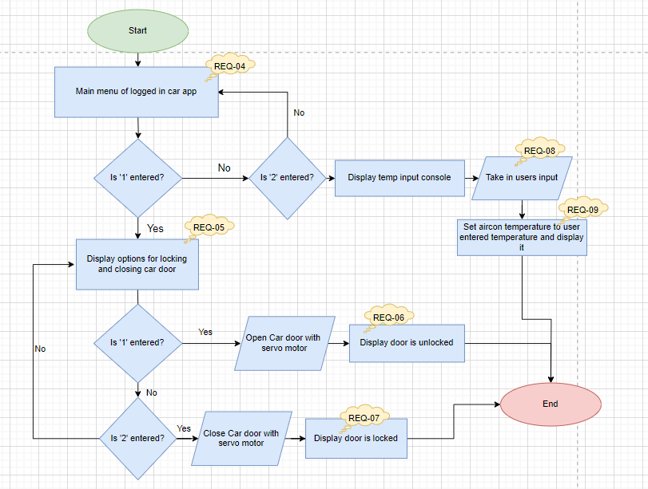

**Figure 2**

2.3.4 Car theft warning

|  |  |
| --- | --- |
| **REQ_ID** | **Requirement** |
| REQ-04 | In the main menu defined in REQ-03, if the option “Enter ‘1’ to power on car” is selected on the keyboard, then the following menu shall be displayed on the web interface.  Line 1 = “Enter 1 to lock/unlock car door”  Line 2 = “Enter 2 to control aircon”  Line 3 = “Fuel level = “  Line 4 = “Temperature = “  Line 5 = “Car Theft Warning: None “ |
| REQ-05 | If car door is forcefully opened despite the door being closed, Car Theft Warning will be triggered and line 5 in the main menu as shown in REQ-04 will be updated, the following menu shall be displayed on the web interface.   Line 1 = “Enter 1 to lock/unlock car door”  Line 2 = “Enter 2 to control aircon”  Line 3 = “Fuel level = “  Line 4 = “Temperature = “  Line 5 = “Car Theft Warning: TRIGGERED “ |

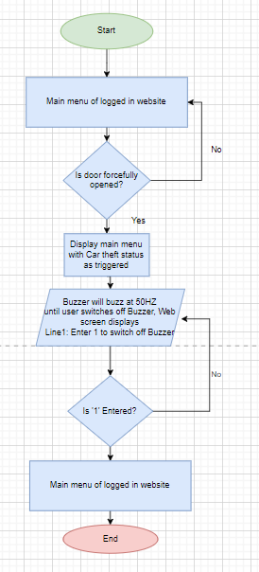

Figure 3

2.3.5 Remote Access

The Vehicle Security and Telematics System supports “Remote Access” to monitor vehicle functions, set events, and control remotely.

|  |  |
| --- | --- |
| **REQ_ID** | **Requirement** |
| REQ-18 | Implement user authentication using login credentials (username and password) for accessing the vehicle remotely. |
| REQ-19 | Optionally, support Two-Factor Authentication (2FA) for enhanced security during login. |
| REQ-20 | Enable remote control functionalities for the driver via smartphone or website, including:   * REQ-20.1: Starting and stopping the car engine. * REQ-20.2: Controlling air conditioning, heating, and other vehicle settings. * REQ-20.3: Monitoring car battery level, fuel status, engine temperature, and other vital parameters. |
| REQ-21 | Allow the driver to lock and unlock the car remotely using Bluetooth Low Energy (BLE) or internet connection from their smartphone or website. |
| REQ-22 | Implement an alarm system that triggers when any door is forcefully opened while all doors are locked. Notify the user via their smartphone or website of a possible theft attempt. |
| REQ-23 | Enable the sharing of the vehicle with at least two different drivers using separate RFID cards. |
| REQ-24 | Require RFID authentication for starting the car engine. Each vehicle supports a maximum of three registered RFID cards at any time. |

2.3.6 Authentication Services

In the car application, user authentication is required before accessing its functionalities. This involves a two-step authentication process to ensure user identity verification.

|  |  |
| --- | --- |
| **REQ_ID** | **Requirement** |
| REQ-21 | Upon launching the web application: The web interface shall display a sign up screen prompting users to enter their credentials.  The sign up screen shall include fields for first name, password, confirm password, email address and verification code. |
| REQ-22 | After signing up, the web interface shall display a login screen prompting users to enter their credentials.  The login screen shall include fields for first name and password. |
| REQ-22 | The web application shall require users to input valid login credentials (e.g., first name and password) to access its functionalities.  Upon successful authentication:  Users shall gain access to the main page of the car application. |
| REQ-23 | After the initial login, the car application shall implement a two-factor authentication (2FA) process to further verify user identity.  The 2FA process shall involve:  Utilizing user’s email authentication.  Users shall be required to successfully complete the 2FA process before accessing the main functionalities of the car application. |

2.4. Non-Functional Requirements

2.4.1. Power Management

The Vehicle Security and Telematics System has 2 Power Modes as defined in the State Machine diagram in Figure 3 below. The transitions between the Low Power Mode and High Power Mode are triggered by the events labelled “evEnterLPM” and “evEnterHPM”.

Conditions for trigger the events are defined in the requirements below.

**Figure 3**



High Power Mode



Low Power Mode



evEnterLPM



evEnterHPM

|  |  |
| --- | --- |
| **REQ_ID** | **Requirement** |
| REQ-24 | **“evEnterLPM” Trigger Condition 1**     * When user selects option to power off the car on keypad. |
| REQ-25 | **“evEnterLPM” Trigger Condition 2**   * When user selects the option “Enter ‘1’ to unlock door” or “Enter ‘2’ to lock door” and option is displayed on screen |
| REQ-26 | **“evEnterLPM” Trigger Condition 2**   * When user enters the desired temperature and it is displayed on the screen. |
| REQ-25 | **“evEnterHPM” Trigger Condition 1**    ▪ When the user enters ‘1’ in the keyboard under the option “Enter ‘1’ to power on car”. |
| REQ-26 | **“evEnterHPM” Trigger Condition 2**   * When any door is forcefully opened and the buzzer alarm starts to sound. |

1. Software Architecture

3.1. Static Software Architecture

The Software Architecture defines the various Software Components that are developed to realize the implementation of the system requirements.



**Application**

**Layer**

DoorForcedOpen.py

Username_checker.py

password_checker.py

EngineStarter.py

TempandHumidityaircon.py

DoorLock_Unlock.py

**Hardware Abstraction Layer (HAL)**

DHT11

Thermostat

Wifi

RFID cards

Servo motor

Buzzer